



Essay / Assignment Title: Project Output

Programme title: Computer Visualization and Story Telling with Tableau

Name: FAISAL KHAN DAHRI

Year: 2025

Contents
Abstract 4
INTRODUCTION 5
Topic 1: Data Pre-Processing 6
Topic 2: Analyzing The Data 9
Topic 2.1: Objectives 10
Topic 3: Dashboard and Story 19
Limitations: 20
Conclusion 21
References 22
Links (Tableau sheets, Dataset, Python code) 23

Statement of compliance with academic ethics and the avoidance of plagiarism

I honestly declare that this dissertation is entirely my own work and none of its part has been copied from printed or electronic sources, translated from foreign sources and reproduced from essays of other researchers or students. Wherever I have been based on ideas or other people texts I clearly declare it through the good use of references following academic ethics.
(In the case that is proved that part of the essay does not constitute an original work, but a copy of an already published essay or from another source, the student will be expelled permanently from the program).

Name and Surname (Capital letters):

...........FAISAL KHAN DAHRI............................................................................................................................

Date: .............14............/...June....../...2025......

Abstract
For the purpose of this project, we will help a client improve their e-commerce business by giving them strategies to improve their marketing and increase user engagement.
We have their e-commerce website traffic dataset, this dataset defines different marketing medium used to gain users, from different part of the world, their conversion rate, the device they used and much more.
We have cleaned the dataset using python, then went on to analyze it using visualization tool ‘Tableau’ to answer the following objectives:
- Identify which part of the world most of our users come from for target advertisement.
- What medium of marketing gained us most conversion rate.
- Which days did we had high session duration and did it directly correlate with high conversion rate.
- We will analyze for the month of June how many new users we gained in comparison to old users, to understand results of our marketing.
- Which device users bought us most users and did more user meant high conversion rate or not.
We then combined our worksheets into an extensive dashboard and summarized our finding in tableau story.
Finally, we have summarized our analysis and given adequate solution as to how the client could strategies to optimize marketing and improve customer engagement to increase their conversion rate.

INTRODUCTION
For this assignment we will look at website traffic dataset for our client who has a e commerce business, who wants to understand the performance of their website to optimize their marketing and to improve engagement of users.
We have the web site traffic dataset for the month of June-2023, the data is gained as a result of a marketing campaign. We will understand and analyze this data to best help the client strategies their future marketing and user engagement based on historic data, this is called descriptive analytics i-e analyzing historical data to understand winning products, market trends, high turnover, marketing strategies, etc.
Primarily, we shall clean the data using Python and then go on to visually analyze it using a visualization tool called ‘Tableau’, shared our gathered insight and give conclude strategies based on them.
For the purpose of this assignment, we have taken a dataset from ‘Kaggle’ called ‘Web Marketing Campaign Performance Analytics’ by Sulaman Ahmed (Link).

Topic 1: Data Pre-Processing
Data pre-processing is very important to clean the data to remove or replace any null value, duplicates, noise, assignment the right data type, etc. to make the dataset optimal for analyzing, an uncleaned dataset may cause deviations and inaccuracies in the final result.
A big gap exists between raw and quality data, which the industry needs, data pre-processing is a key step to get that high quality data (Luengo et al., 2020).
Null Values and Duplicates
Null values are any missing values from our data set and duplicated are any duplicated values both of these cause unnecessary noise and deviation in our data set, we will see whether we have any null or duplicate values in our dataset using python.
Link to all python code used (Link).
Code 1.1: Python Code to find any Null or Duplicate Values
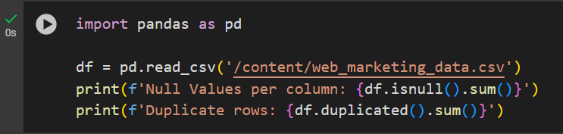
We used python programing language with code editor ‘Google Collab’ to clean our dataset. Python is known for its speed and efficiency for data cleaning. We used pythons built in pandas library used for data analysis to look for any null or duplicate values if present.
Raw data is rarely useable and hence, needs to be refined cleaned, transformed and reduced (Ghosh, 2022).

Figure 1.1: Result of above code
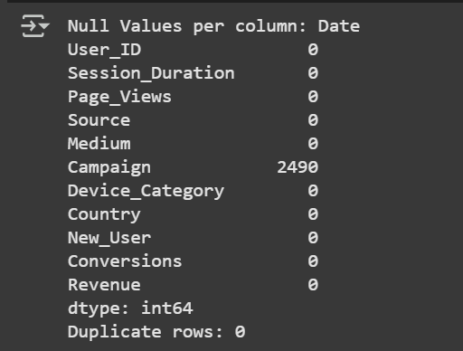
As the result of the above code, we have no duplicate values and no null values for all columns except for ‘Campaign’ column where we have 2,490 null values. Looking at the dataset we discovered that the traffic was coming despite the medium of marketing no assigned to any campaign hence, dropping the rows with null values would cause us a great loss of data therefore, we shall rename these missing values as ‘Others’, significant that other campaigns were done to gain that traffic.
Code 1.2: Renaming Missing Values as No Campaign and Saving the Cleaned File

We have renamed the milling values to ‘Others’ due to reasons defined above and then we save our new cleaned dataset as an excel file. As per the last step of data cleaning we need to assign the right data type to our data columns. For this, we shall connect our excel file to our visualization tool ‘Tableau’, then assign the right data type to our data columns if needed.
Figure 1.2: Data Type Solution
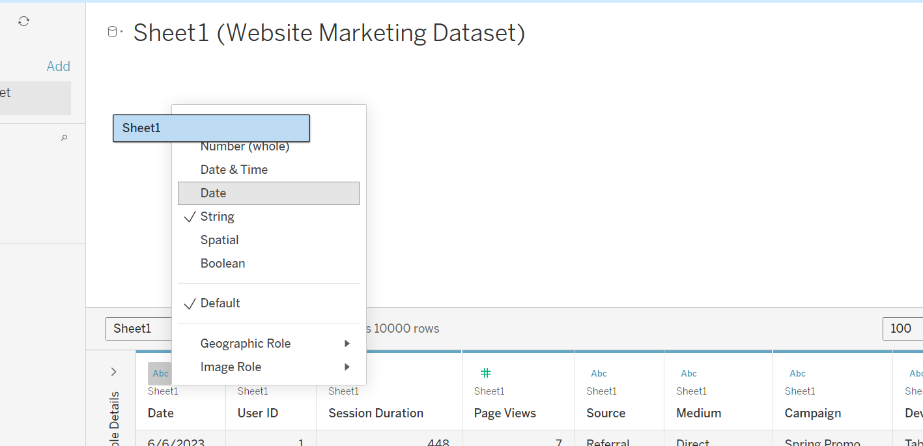
We connected our new cleaned dataset with Tableau, Tableau is a visualization tool used to analyze the data visually with the help of differ charts and graphs, it can be used for different mathematical function as well as for data cleaning.
We used Tableau to transform our date column assigning it the right data type as seen in figure 1.2, as for the rest of the data column they already have the appropriate data type assigned to them. If our data column has the wrong data type assigned to them if causes problem for the computer in our case for tableau to digest them hence, causing improper analytics.
Hence, with this our data pre-processing has been completed and our data is ready for analyzing.
About 90% of the time in the process of data analytics, data visualization and for machine learning project in spent in data pre-processing (Jafari, 2022).

Topic 2: Analyzing The Data
Furthermore, as our dataset is cleaned, we may move on to analyze it. Forehand, we will look at our Key performance indicators (KPI’s), which shall give us in dept understand of our dataset, define what each of our data column represent, this shall help us to better understand and optimize our further analysis of the dataset.
Data Columns/ KPI’s:
- Session duration – Duration of user session in seconds.
- Page views – Number of pages view during the session
- Source – Origin of user traffic (direct, referral, social, organic)
- Medium – Marketing medium used
- Campaign – The campaign season
- Device category – Type of device used by user
- Country – Users location
- New user – 1 for new 0 for return user
- Conversion – No of conversion attributed to the user
- Revenue – Revenue generated from the user during the session

User friendly websites have a very high user engagement necessary for today’s online entrepreneurs (Weinlich et al., 2020).

Topic 2.1: Objectives
Moreover, we shall set out our objective, to give an outline structure to what insights are we trying to achieve with the analysis of our dataset using tableau.
Objectives:
- Identify which part of the world most of our users come from for target advertisement.
- What medium of marketing gained us most conversion rate.
- Which days did we had high session duration and did it directly correlate with high conversion rate.
- We will analyze for the month of June how many new users we gained in comparison to old users, to understand results of our marketing.
- Which device users bought us most users and did more user meant high conversion rate or not.
Data visualization is a key requirement for data literacy and in top demand by employers. And a free tool widely used in the industry for this purpose is Tableau (Batt et al., 2020).

Objective 1: Identify which part of the world most of our users come from for target advertisement.
Figure 2.1: Worl Map Showing Countries with Most Users (Link)
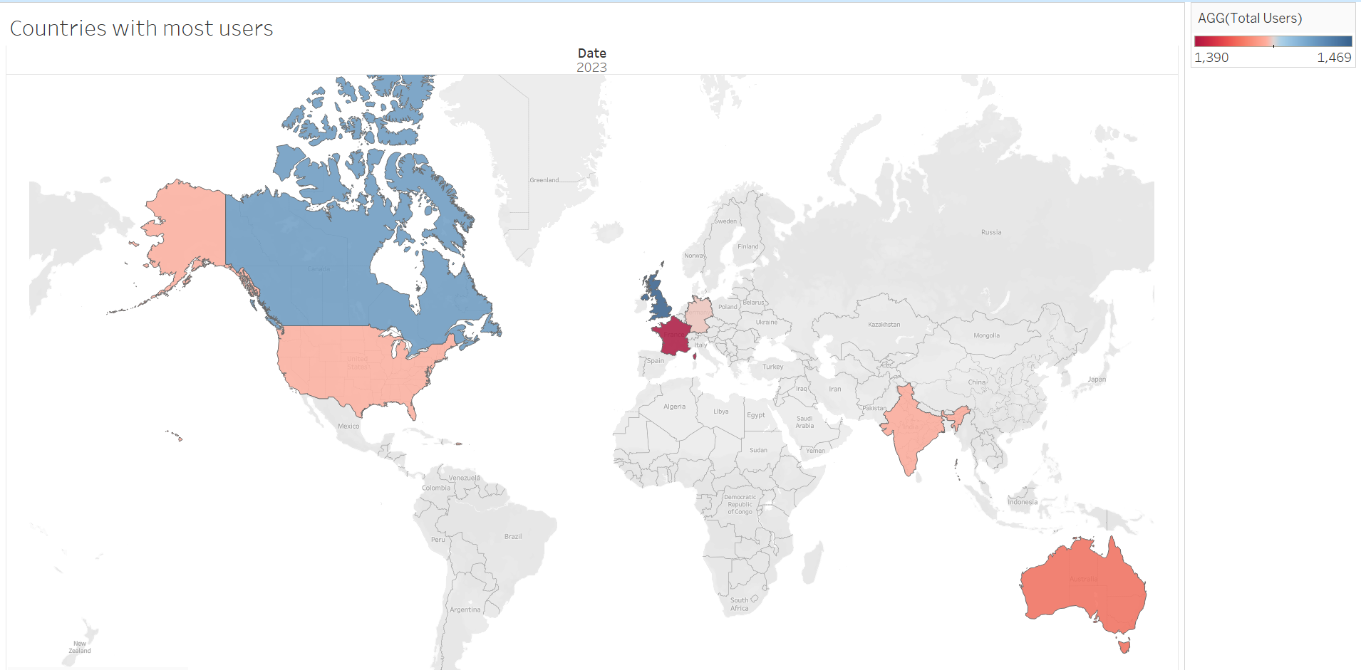
This world map shows us which countries hold the most amount of our customers which include countries such as Australia, India, France, Germany, UK, Canada and USA. Though the top 3 countries with most of our customers are in France, Germany and UK in comparison to percentage of user’s vs overall population.
Hence, we can use this data to target advertise our existing customer base and gain more market share in other counties where we lack it.

Objective 2: What medium of marketing gained us most conversion rate.
Figure 2.2: Pie Chart showing Conversion rate and session duration in relation to Medium of Advertisement (Link)
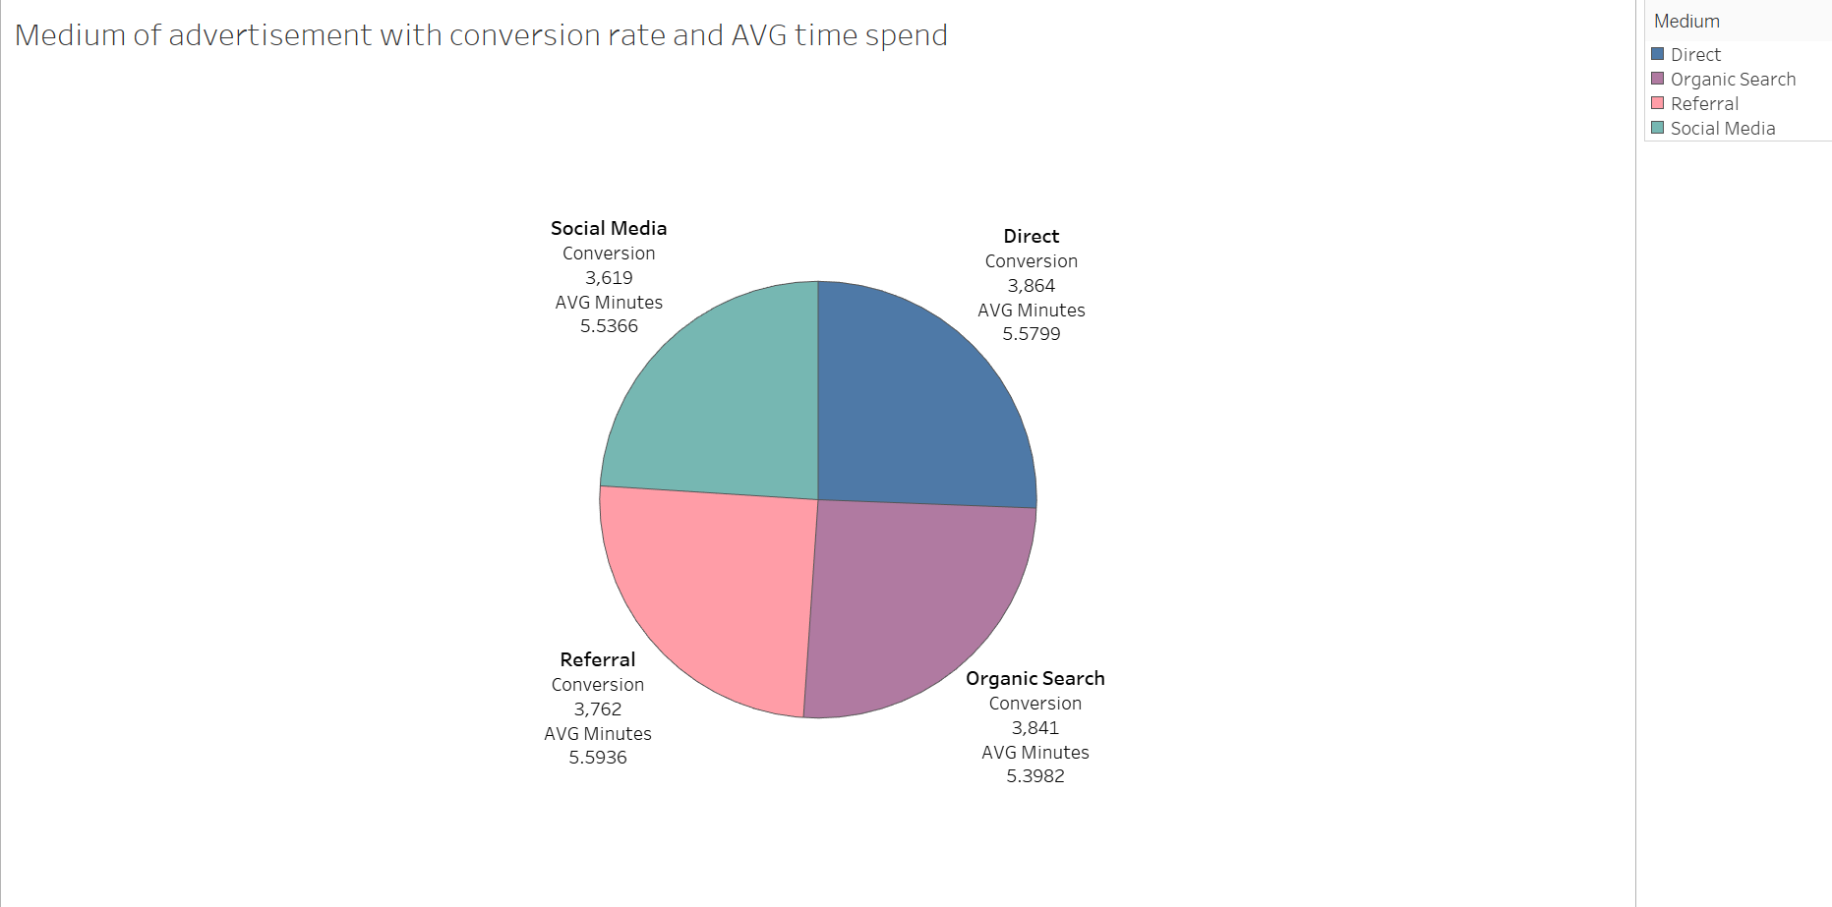
Here as per this pie chart we can see the most amount of people arrives on our website by direct ways i-e manually visiting through the URL of the web page =, seconded by organic search which means through search engine searches such as google. They both did not need any sort of advertisement but a website has to have very good review, needs to by optimized with good key words to rank higher on search engines and need good word of mouth for customers to get in directly using the URL because the numbers of conversion gain by these two metrics are very good.
Nonetheless, other two means used such as referral and social media advertisement has also got us amazing number of conversions. Whereas, the average duration of session seems to be almost the same in all of them.
To understand the effectiveness of these medium of advertisement we need to see how many new customers i-e market growth have we achieved which we shall do so under objective 4.
It shall also be mention that here to showcase the duration of session in minutes instead of seconds for better understanding, we created a calculated field shown below.
Figure 2.3: Calculated Field to convert duration of session into minutes
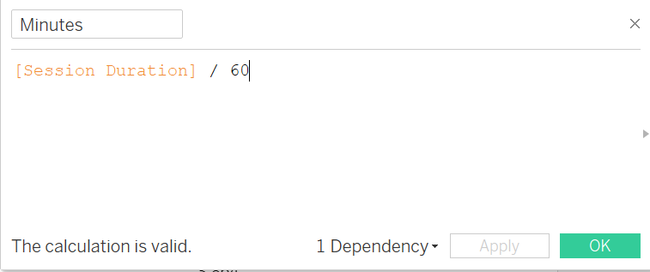
Here to get convert duration of session form seconds to minutes we simple divided it with 60.

Objective 3: Which days did we had high session duration and did it directly correlate with high conversion rate.
Figure 2.4: Bar Line Chart showing Duration of session by no of conversion over time (Link)
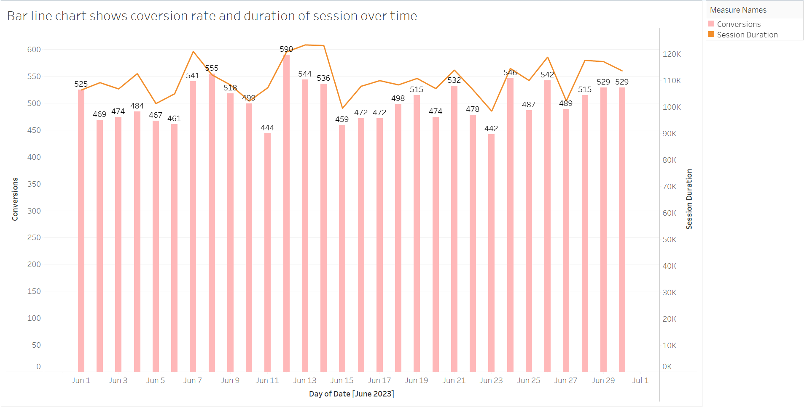
This bar line chart shows the duration of session and the number of conversions over a period of time. This chart will help us understand whether longer duration of session will result in high conversion rate or not. The line represents the duration of session while the bars represent the number of conversions.
Our chart indicates that an increase in duration of session as seen on 12th, 13th and 14th of June we see most high rates of conversion 590, 544 and 536 respectively. This clarifies that our e- commerce site needs to be more engaging so that the user will spend more time on it which will more likely result in a higher conversion rate as discovered by this bar line chart.

Objective 4: We will analyze for the month of June how many new users we gained in comparison to old users, to understand results of our marketing.
Figure 2.5: Donut Chart Comparing Number of Old VS New Users gained during June (Link)
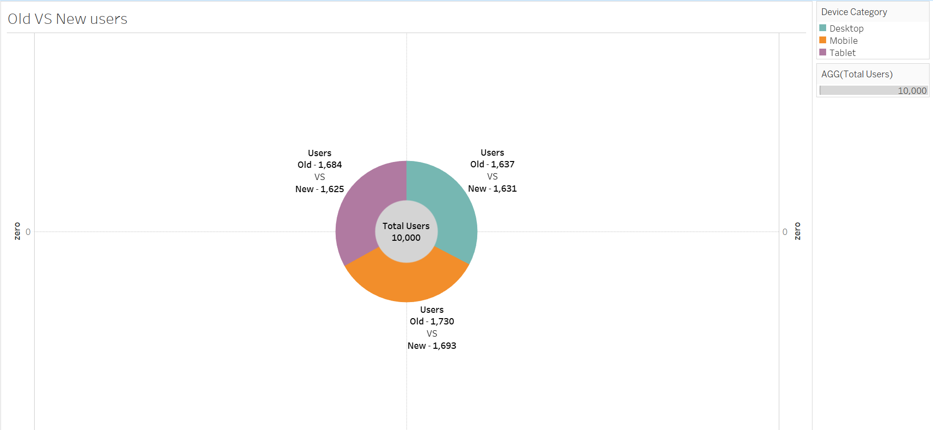
This donut chart compares the number of old vs new users we have gained during just the month of June by our different medium of advertisement and campaigns.
We used the dimension ‘Device category’ which is not relevant to our analysis. Moving on we see that of all 10,000 users we had on our website for the month of June we see that almost half of it 4,949 were new users, which is an astonishing number.
This number notifies us of the effectiveness of our marketing which gave us a high number of new users almost as much as our previous users combined just for the month of June.
For this chart we had to create two new measures ‘Total users’ and ‘Old users’, as seen below.

Figure 2.6: Calculated field to calculate Total users
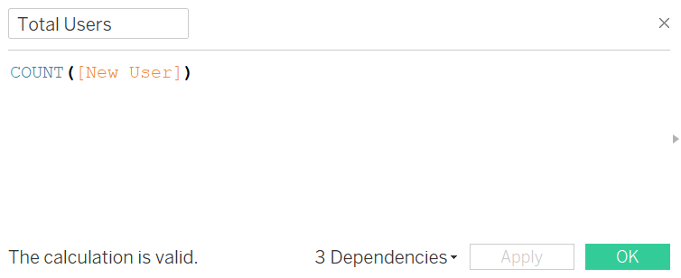
Figure 2.7: Calculated field to calculate old users
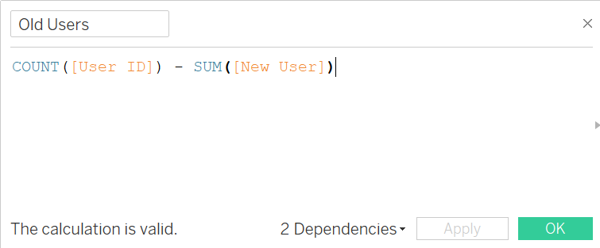
These two calculated fields show how we created two new measures for the purpose of our Donut chart i-e ‘Total users’ and ‘Old users’.
Objective 5: Which device users bought us most users and did more user meant high conversion rate or not.
Figure 2.8: Side by Side Bar Chart showing type of device total users Vs conversion (Link)
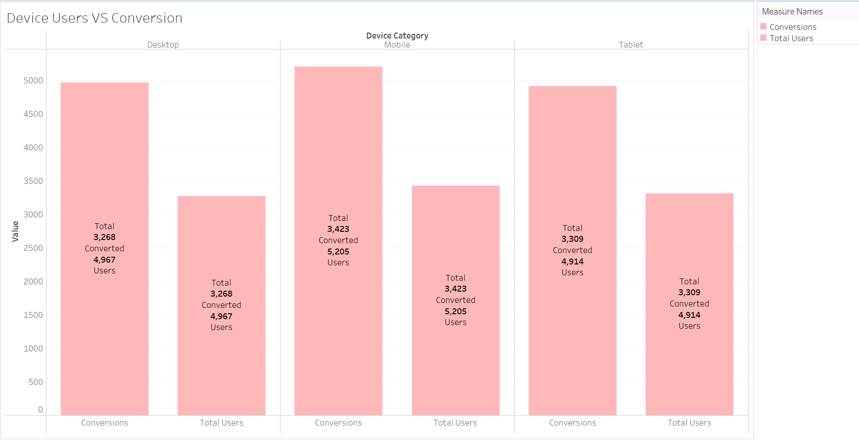
We will use this side-by-side bar chart to answer the question which device category are the most users coming from and does the higher users from a particular device means higher conversion rate.
We see as per the chart above that the number of mobile users exceed followed by desktop and tablet. And high number of users using mobile did result in higher conversion rate but now in every case as although we have higher user using tablet than desktop but desktop resulted in higher no of converts than tablet.
The conversion rate exceeds even the number of users as further elaborated in this Lollipop Chart
Figure 2.9: Lollipop chart showing how conversion exceed no of user (Link)
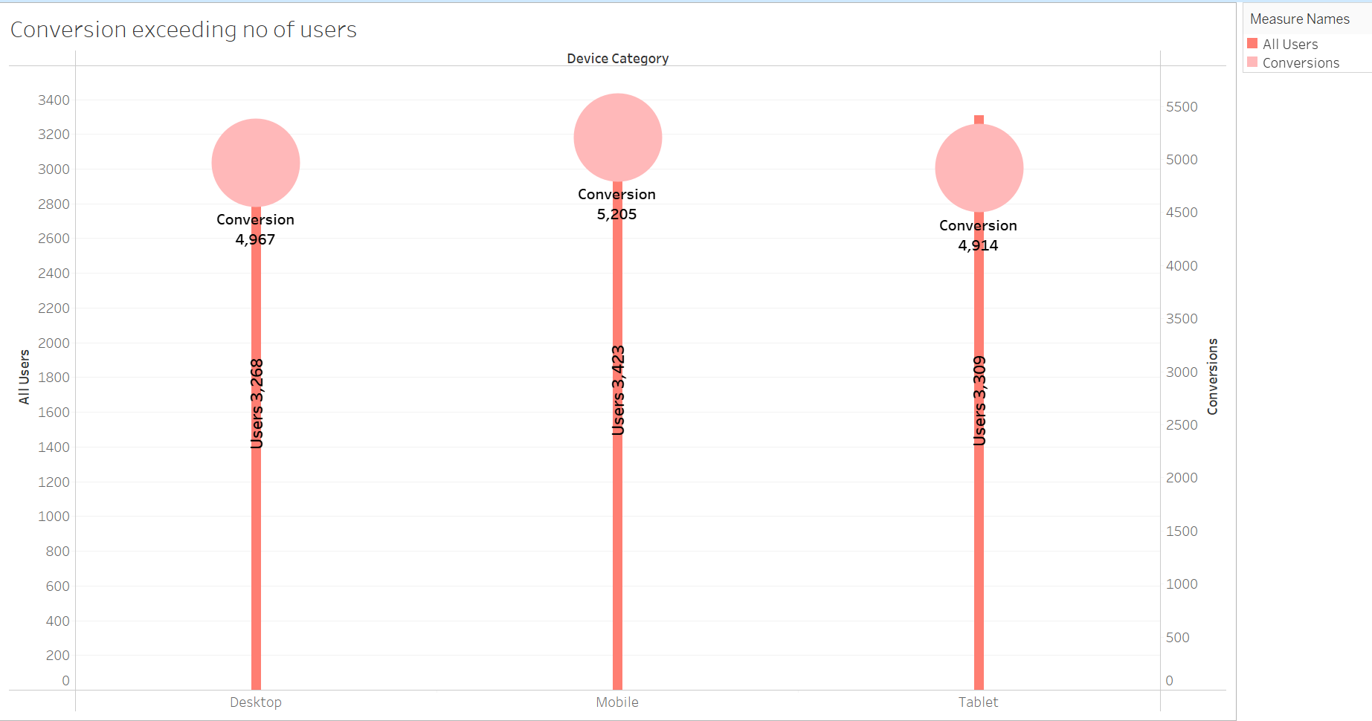
We have high rate of conversion even more than the engaged users is due to most users buy more than one item and they usually return to buy more.
Our analysis under objective 5 concludes that we have a lot more user with tablets but less conversion rate this is vice versa when compared to desktop, this might be because the website might be less user friendly when accessed with a tablet hence, efforts should be put in to understand the gap in conversion rate by tablet and the customer experience should be improved on tablets.

Topic 3: Dashboard and Story
Furthermore, we will create a ‘Tableau Dashboard’, used for to communicated finding with other stakeholders whereas, ‘Tableau Story’ is used to visually represent work sheets in a sequential manner as telling a story.
Figure 3.1: Tableau Dashboard (Link)
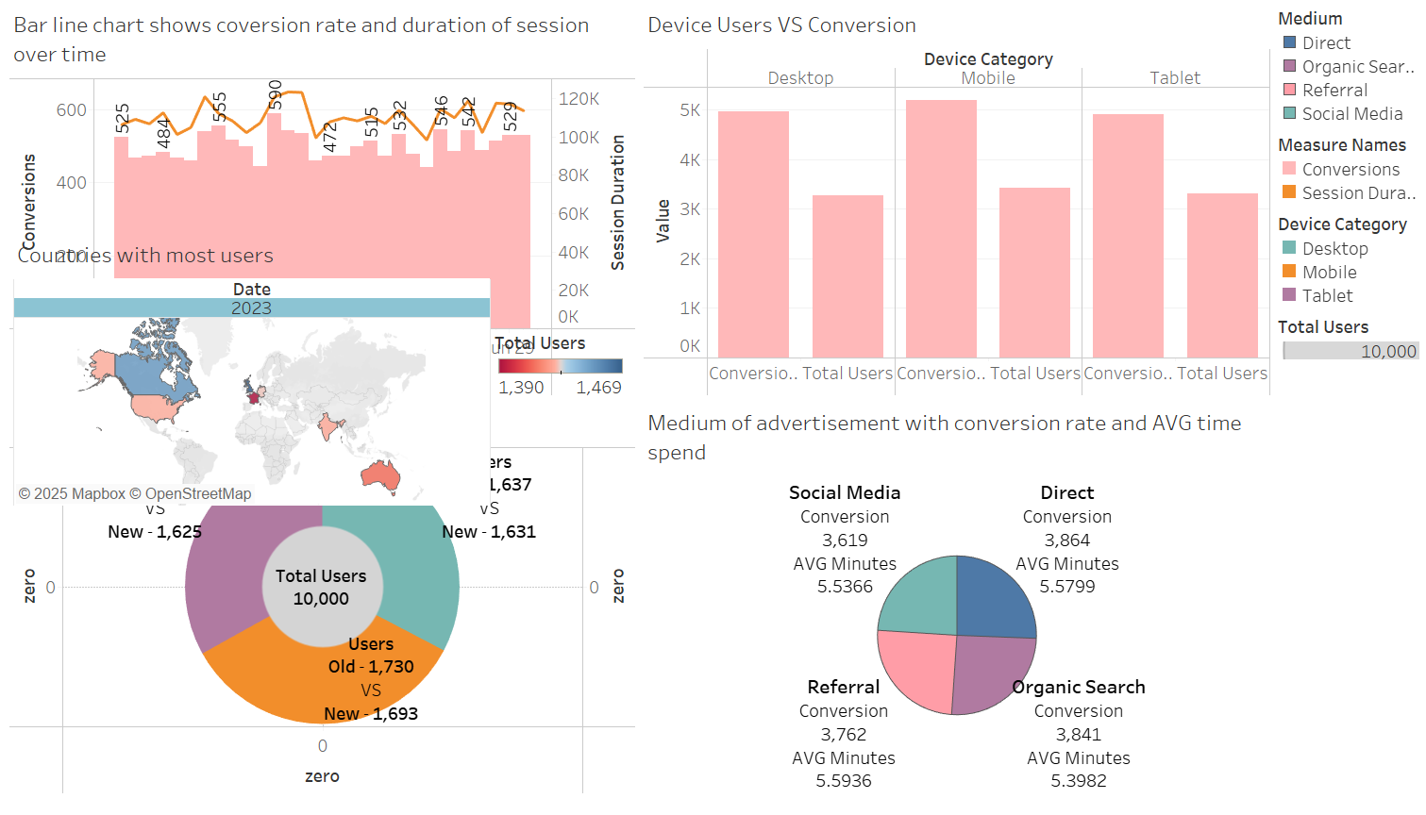
Our tableau dashboard represents all the sheets that we have worked on in a beautiful presentable manner, these sheets could be further filtered down using the filers on the right-hand side of the terminal to communicate our finding effectively.

Figure 3.2: Tableau Story (Link)
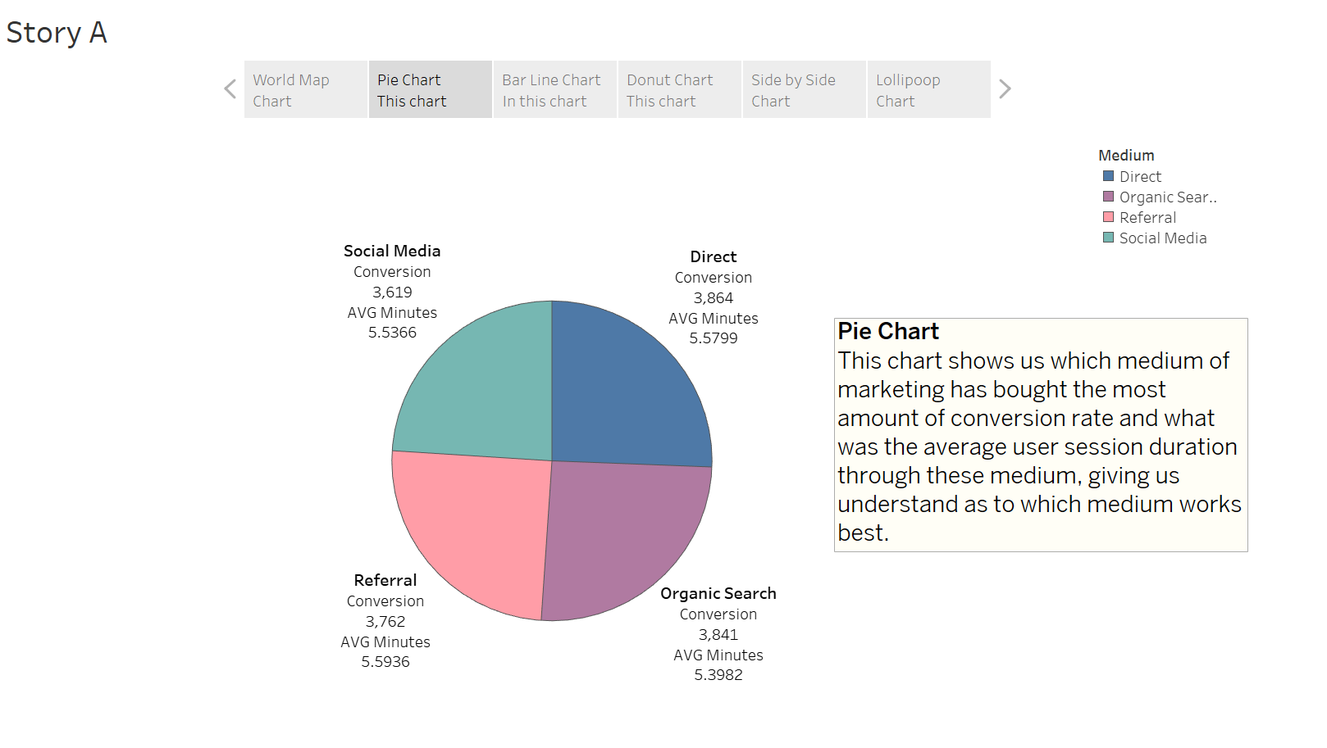
Our tableau story showcases all the sheets that we have worked on as discussed above in detail, our story also narrates in a sequential manner in a small text box on the right side of the panel as to what we are trying to accomplish with this visualization.
We were not able to show all slide within our story but link for the entire tableau story is provided ().

Limitations:
We observed some limitations to the dataset which that they done show the landing and existing page that the customer is catered to. This data can be used to optimize the landing page and make observation as to what pages users usually exit at so they may be optimized to improve user engagement.
Data driven marketing has gained popularity as companies want to leverage market data to strategies and optimize informed decision making (Dias et al., 2023).

Conclusion
As per the conclusion of the project based on the data analysis we have conducted above, we will argue that a good job has been done marketing as data shows for the month of June, as we have seen an astonishing number of new visitors as much as the number of old visitors who have visited the website elaborated in the ‘Donut Chart’ above.
Marketing mediums such as referrals and social media has gained us great numbers which can be further pushed up and worked on. Nonetheless, great number from organic medium and direct users were also seen, this happens due to reasons such as good word of mouth and optimal key words usage which ranks a website on top of search engines resulting in more organic users, as illustrated by the ‘Pie chart’ in figure 2.2.
Further, we will argue that countries such as France, Germany and UK should be targeted for advertisement although we see that same amount of users we find in Inda, USA, Australia and Canada as seen in ‘World map’ above but, when seen holistically, ratio to entire population we observed with less advertisement expenditure in UK, France and Germany we can gain even more users due to higher likeability ratio for our e-commerce store in these country when compared to others.
We also observed that we have a high user number coming from tablet users but less conversion rate when compared with desktop users where we have less users but high conversion, we have determined that this may be due to the website on tablet not being user friendly hence, we recommend that the website should be optimized and made tablet friendly to increase conversion rate. Also holistically speaking we have observed that higher session duration means higher conversion rate as explained above using ‘Pie chart’ therefore, the website should be made more engaging for all users no matter what device they are using as higher time spent on the web pages will more likely result in higher conversion rate. Customer should be given recommendation based on previous purchases and real time data should be used to recommend on site user based on the pages they are looking at.
Hence, we would recommend the client to adopt the above-mentioned strategic solutions for target marketing, increasing user engagement, optimizing the engagement into higher conversion numbers hence, potentially resulting in higher profitably.

References
Luengo, J., García-Gil, D., Ramírez-Gallego, S., García, S. and Herrera, F., 2020. Big data preprocessing. Cham: Springer, 1, pp.1-186.
Ghosh, C., 2022. Data Pre-processing. In Data Analysis with Machine Learning for Psychologists: Crash Course to Learn Python 3 and Machine Learning in 10 hours (pp. 55-85). Cham: Springer International Publishing.
Jafari, R., 2022. Hands-On Data Preprocessing in Python: Learn how to effectively prepare data for successful data analytics. Packt Publishing Ltd.
Semerádová, T., Weinlich, P., Semerádová, T. and Weinlich, P., 2020. Using Google Analytics to examine the website traffic. Website Quality and Shopping Behavior: Quantitative and Qualitative Evidence, pp.91-112.
Batt, S., Grealis, T., Harmon, O. and Tomolonis, P., 2020. Learning Tableau: A data visualization tool. the Journal of economic education, 51(3-4), pp.317-328.
Rosário, A.T. and Dias, J.C., 2023. How has data-driven marketing evolved: Challenges and opportunities with emerging technologies. International Journal of Information Management Data Insights, 3(2), p.100203.

Links (Tableau sheets, Dataset, Python code)
Tableau Sheets:
https://public.tableau.com/views/WorldMapCountrieswithmostusers/Countrieswithmostusers?:language=en-US&:sid=&:redirect=auth&:display_count=n&:origin=viz_share_link
https://public.tableau.com/views/PieChartMediumofadvertisementwithconversionrateandAVGtimespend/MediumofadvertisementwithconversionrateandAVGtimespend?:language=en-US&:sid=&:redirect=auth&:display_count=n&:origin=viz_share_link
https://public.tableau.com/views/Barlinechartshowscoversionrateanddurationofsessionovertime/Barlinechartshowscoversionrateanddurationofsessionovertime?:language=en-US&:sid=&:redirect=auth&:display_count=n&:origin=viz_share_link
https://public.tableau.com/views/DonutChartOldVSNewusers/OldVSNewusers?:language=en-US&:sid=&:redirect=auth&:display_count=n&:origin=viz_share_link
https://public.tableau.com/views/SidebySideBarChart-DeviceUsersVSConversion/DeviceUsersVSConversion?:language=en-US&:sid=&:redirect=auth&:display_count=n&:origin=viz_share_link
https://public.tableau.com/views/LollipopChart-Conversionexceedingnoofusers/Conversionexceedingnoofusers?:language=en-US&:sid=&:redirect=auth&:display_count=n&:origin=viz_share_link
Tableau Dashboard and Story:
https://public.tableau.com/views/DashboardA_17499256505320/DashboardA?:language=en-US&:sid=&:redirect=auth&:display_count=n&:origin=viz_share_link
https://public.tableau.com/views/StoryA_17499256830070/StoryA?:language=en-US&:sid=&:redirect=auth&:display_count=n&:origin=viz_share_link

Dataset:
https://www.kaggle.com/datasets/sulaimanahmed/web-marketing-campaign-performance-analysis?resource=download&select=web_marketing_data.csv

Python code for data cleaning/pre-processing:
https://github.com/FaisalDahri/Tableau-Assignment-1-py-code.git

